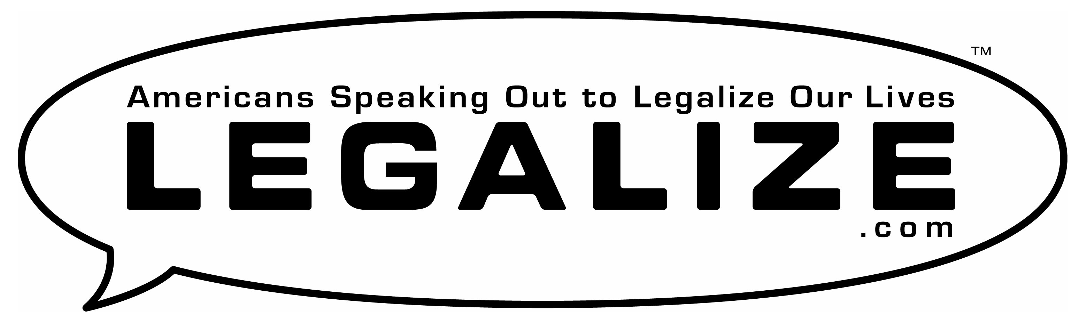

Legalize Nightlife

● Repeal the Cabaret Laws that ban dancing in bars.
● Permit smoking in bars equipped with air filtration
that protects the health of workers and patrons.
● Defeat Bloomberg’s proposed 1:00am closing time.

Petitions ● Flyers ● T-Shirts ● Campaigns ● Lobby Days ● Activism

